**Software Testing Assignment**

**Module -1(Fundamental)**

1. **What is SDLC?**

* The software development lifecycle (SDLC) is the **cost -effective and time -efficient process that development teams use to design and build high -quality software.**
* The goal of SDLC is to minimize project risks through forward planning so that software meets customer expectations during production and beyond.

1. **What is Software Testing?**

* Testing is the process of evaluating a system or its component with the intent to find that whether it satisfies the specified requirement or mot.
* Testing is executing a system in order to identify any gaps, error or missing requirement in contrary to the actual desire or requirements.

1. **What is Agile Methodology?**

* The Agile methodology is a way to manage a project by breaking it up into several phases.
* It involves constant collaboration with stakeholder and continuous improvement at every stage.

1. **What is SRS?**

* A Software requirement specification (SRS) is a document than describes. it also what the software will do and how it will be expected to perform . it also describes the functionality the product needs to fulfil to the need of all stakeholders (business, users)
* Types of Requirements:
* Customer Requirement
* Functional Requirement
* Non -Functional Requirement

1. **WHAT IS OOPS ?**

* Identifying **objects** and assigning **responsibilities** to these objects.
* Object communicate to other objects by sending **messages**.
* Message are received by the **methods** of.
* An object
* **An object is like a** **black box.**
* **The internal details are hidden**.
* Object is derived from abstract data type
* Object- oriented programming has a web of interacting object, each house -keeping its own state.
* Object of a program interact by sending message to each other

1. **Write Basic Concepts of oops**

-Object

-Class

-Encapsulation

-Inheritance

-Polymorphism

-Overriding

-Overloading

-Abstraction

**(7)** **What is Object?**

- An object represents an individual, identifiable item, unit, or entity, either real of abstract, with a well -defined role in the problem domain.

- that is both data and function that operate on data are bundled as a unit called as object.

**(8) What is Class?**

- Aclass is a way organizing information about type of data so a programmer can reuse elements when making multiple instance of that data type

- if a programmer wanted to make three cars, maybe a Ferrari Nd ford.

**(9) What is encapsulation?**

**- encapsulation is the practice of including in an object everything it needs hidden** **from other objects. the internal state is usually not accessible by other objects.**

(**10) What is inheritance**?

-inheritance means that one class inherits the characteristics of another class. This is also called a “is a “ relationship

-one of the most useful aspects of object – oriented programming is code reusability. As the name suggests inheritance is the exiting class called as base class , new class is formed called As derived class.

- this is very important concept of object -oriented programming since this feature helps to reduce the code size.

**(11) What is polymorphism**

**-**Polymorphism means “having many forms”.

-it allows different object to respond to the same massage in different ways, the response specific to the type of the object.

**(12)** **Draw USECASE on online book shopping**

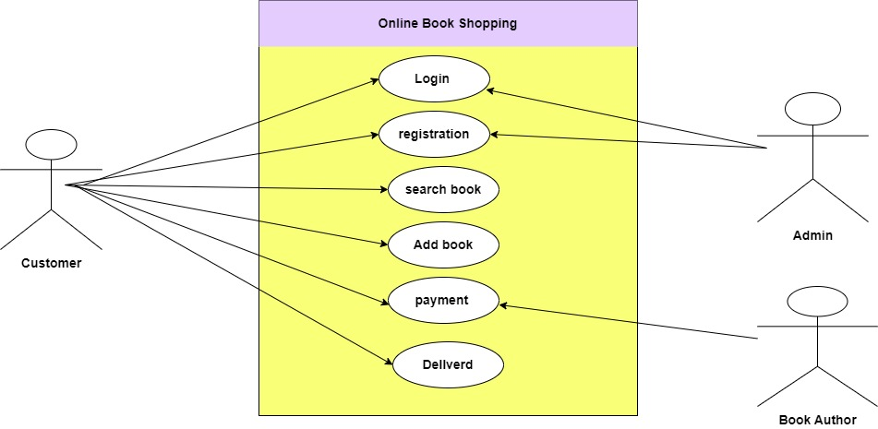

**(13)** **Draw USECASE on online bill payment system (PAYTM)**

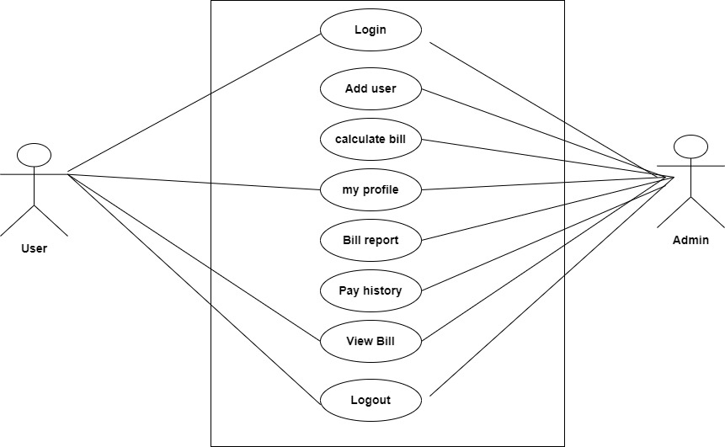

**(14) write SDLC phases with basic information**

**\*Requirements:**

- Planning for the quality assurance requirement and of the risks involved is also done at this stage.

- this stage gives a clearer picture of the scope of the entire project.

* **Analysis:**

- The analysis phases Defines the requirement of the system, independent document.

- The deliverable result at the end of this phase is a requirement document.

**\*Design:**

**-** in this phases the requirement gathered in the SRS document is used as an input and software architecture that is used for development in this phases.

**\*Testing:**

**-** in this phase the developed software is tested thoroughly and defect found are assigned to developers to get them fixed.

**\*Maintenance**:

- software maintenance is one of the activities in software engineering, and is the process of enhancing and optimizing developed software as well as fixing defects.

**(15) Explain phases of the waterfall model**

\***Requirement Gathering and analysis:**

**-** All possible requirement of the system to be developed are captured in this phase and documented in are requirement specification document.

**\* System Design:**

**-** The requirement specification from first phase are studied in this phase and the system design is prepared. This system design helps in Specifying

- hardware and system requirement and helps in defining the overall system architecture.

\***Implementation:**

**-** with inputs from the system design, the system is first developed in small called units, which are integrated in the next. Phase. Each unit is

- developed and tested for its functionality, which is referred to as unit testing.

* **Integration and Testing**

- All the units developed in the implementation phases are integrated into a system after testing of each unit . post integration the tested for any faults and failures.

\***Deployment of system:**

**-** once the functional and non -functional testing Is done; the product is deployed in the customer environment or released into the market.

\***Maintenance:**

-There are same issues which come up in the client environment. to fix those issues, patches are released. Maintenance is done to deliver these changes in the customer environment.

**(16) Write phases of spiral model**

**-** identify objectives

- Risk analysis

- product development

- planning or evaluation

**(17) Explain working methodology of agile model and also write pros and cons.**

- Agile SDLC model is a combination of iterative and incremental process models with focus on process adaptability and customer satisfaction by repaid delivery of working software product.

Agile methods break the product into small incremental builds.

* Design, coding, util testing, and acceptance testing.

*Pros:

- Is a very realistic approach to software development

- Promotes teamwork and cross training.

- Functionality can be developed rapidly and demonstrated.

- Resource requirement are minimum.

- Suitable for fixed or changing requirements

- Delivers early partial working solution.

- Good model for environments that change steadily.

- Little or no planning required

- Easy to manage

*Cons:

- Not Suitable for handling complex dependencies.

- More risk of sustainability. Maintainability and extensibility.

- An overall plan, and agile leader and agile pm practice is must without which it will not work.

- strict delivery management dictates that scope, functionality to be delivered, and adjustments to meet the deadlines.

- depends heavily on customer interaction, so if customer is not clear, team can be driven in the wrong direction.

- Strict delivery management dictates the scope, functionality to be delivered, and

Adjustments to meet the deadlines.

* There is very high individual dependency, since there is minimum documentation generated.
* Transfer to technology to new team them members may be quite challenging due to lack of documentation.

**(18) Write Agile manifesto principles**

- The twelve Agile manifesto principle

- Customer satisfaction through early and continue software delivery.

- Accommodate changing requirement through requirement throughout the development process

- frequent delivery of working software

- collaboration between the business Stakeholders and developers throughout the project

- support, trust, and motivate the people involved

- Enable face-to-face interactions.

-Working software is the primary measure of progress

- Self-organizing teams encourage great architecture requirement and designs.

(19) Draw USECASE On online shopping product using COD.

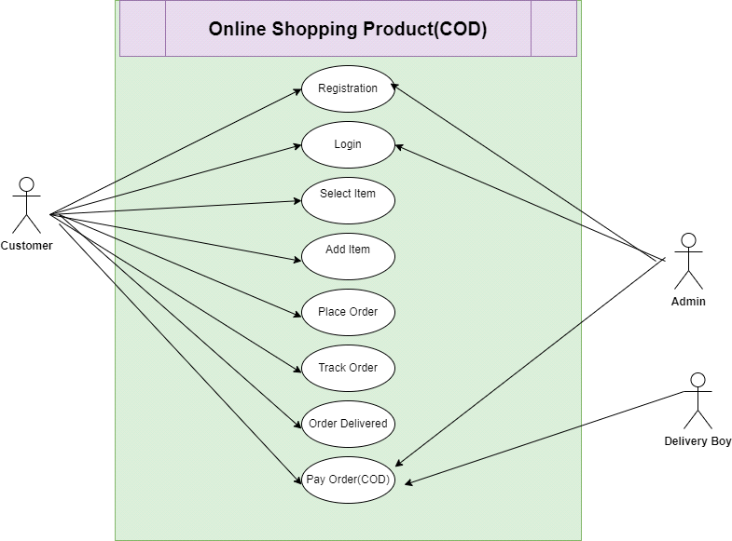

**(20) Draw USECASE on online shopping product using payment gateway.**

